Supplementary Material Figures S1–S17
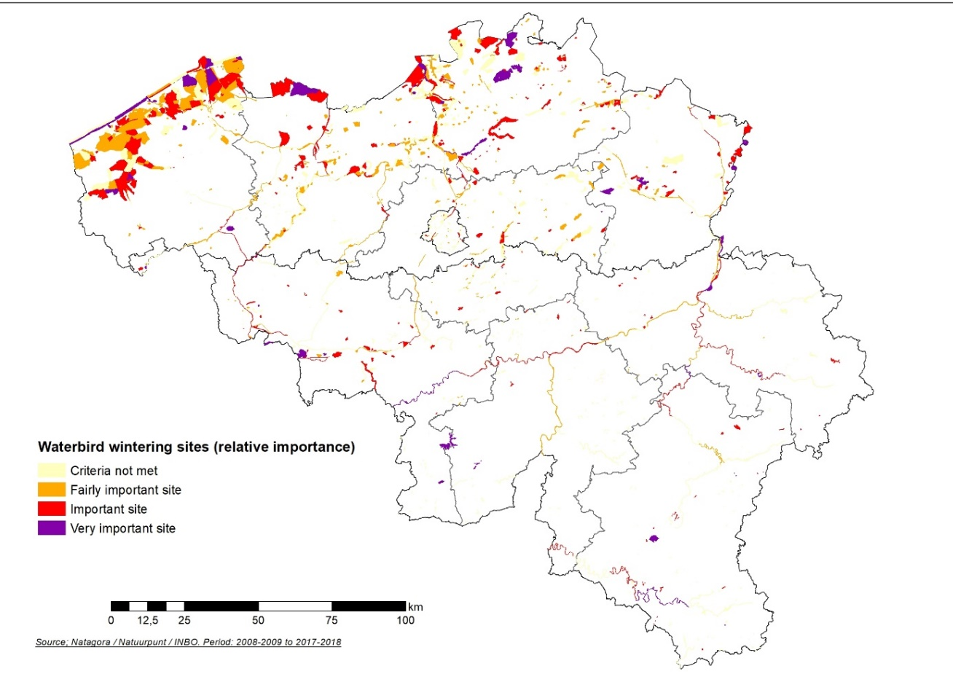
Figure S1:Layer of important sites for wintering waterbirds.in Belgium based on the 2008-2009 / 2017-2018 counts.
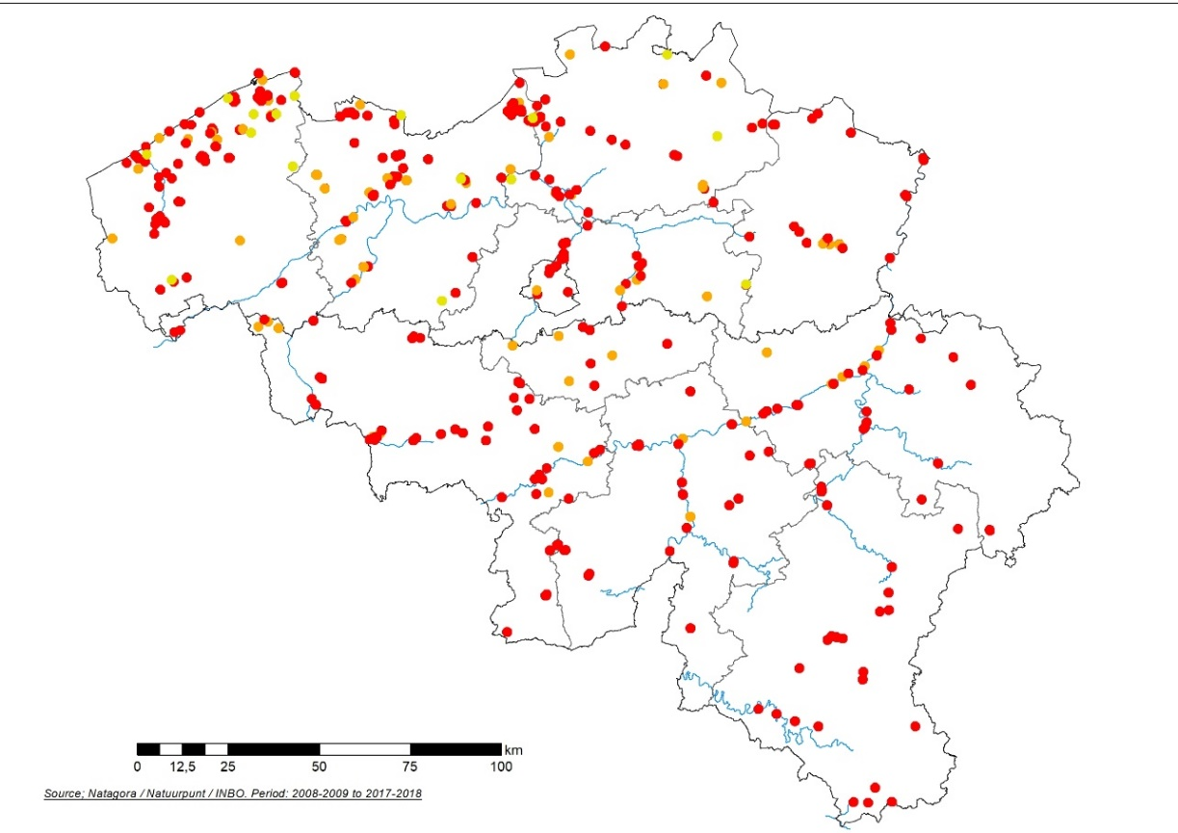
Figure S2: Locations of roosts identified for several sensitive species. “Very important roosts” are in red, “important” in orange, “fairly important” in yellow.
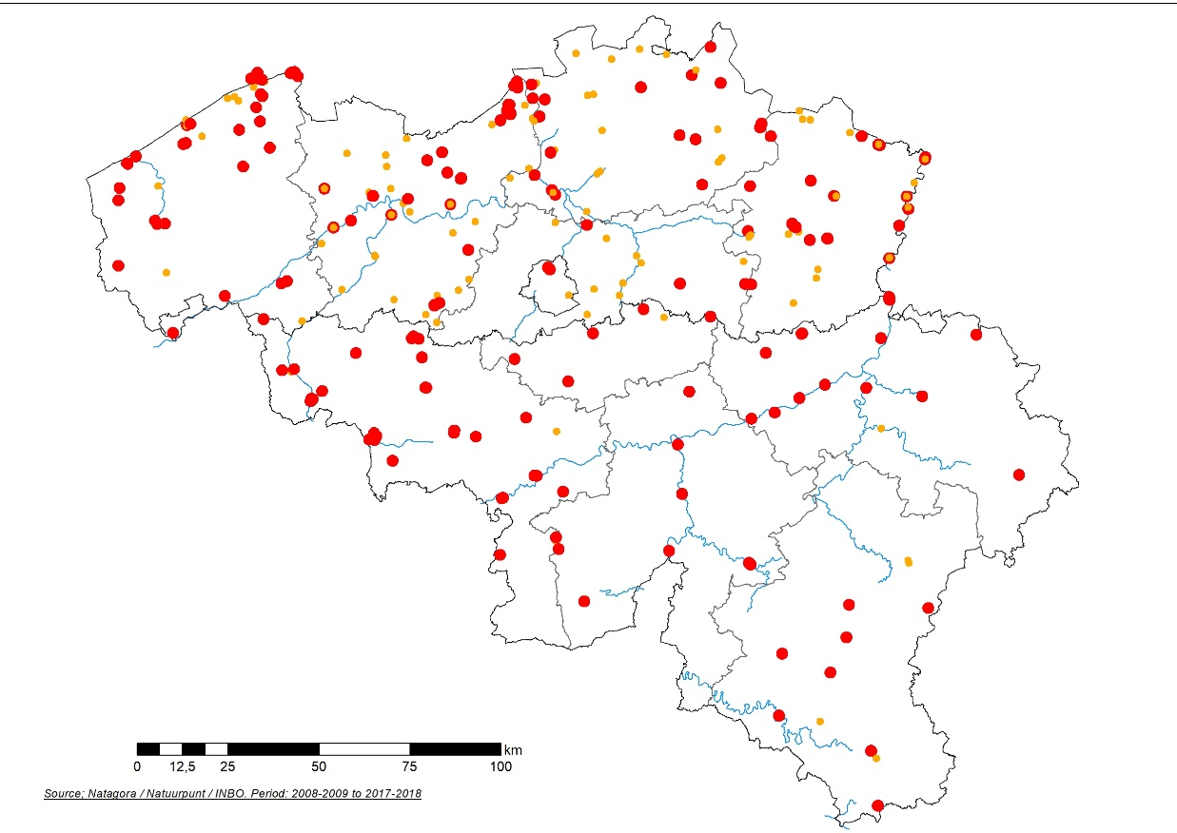
Figure S3: Layer map of colonies of sensitive breeding bird species in Belgium for the period 2010-2019. Red dots are “Very important sites”, orange are “Important sites”.
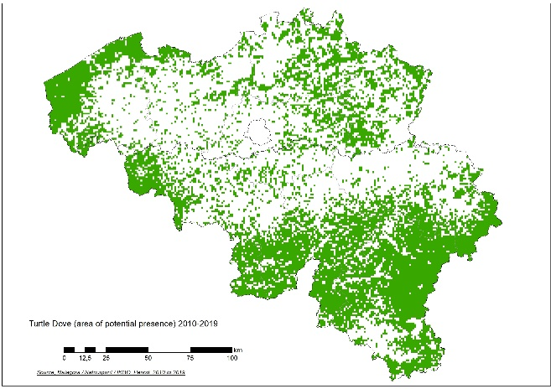
Figure S4: Modelled map for the presence of the Turtle Dove Streptopelia turtur in Belgium (green denotes where the model predicts the species to be present as a breeding bird, period 2010-2019).
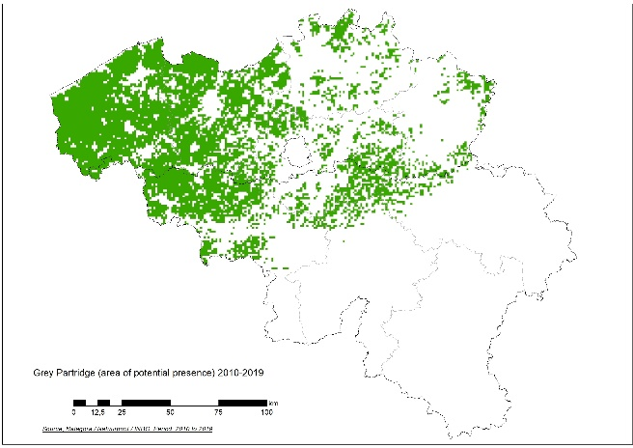
Figure S5: Modelled map for the presence of the Grey Partridge Perdix perdix in Belgium (green denotes where the model predicts the species to be present as a breeding bird for the period 2010-2019.
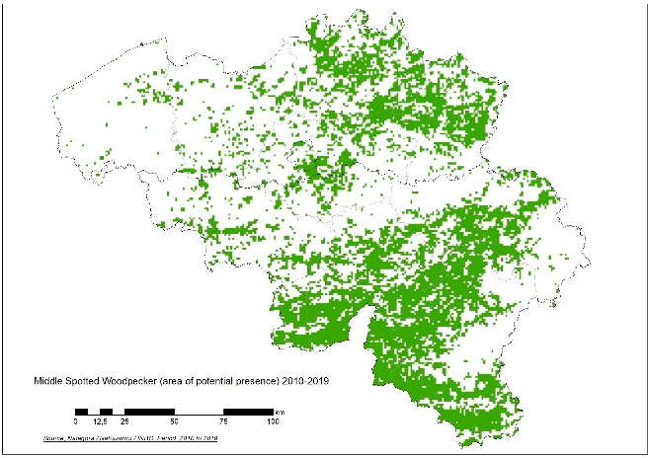
Figure S6: Modelled map for the presence of the Middle-Spotted Woodpecker Leiopicus medius in Belgium (green denotes where the model predicts the species to be present during the period 2010-2019.
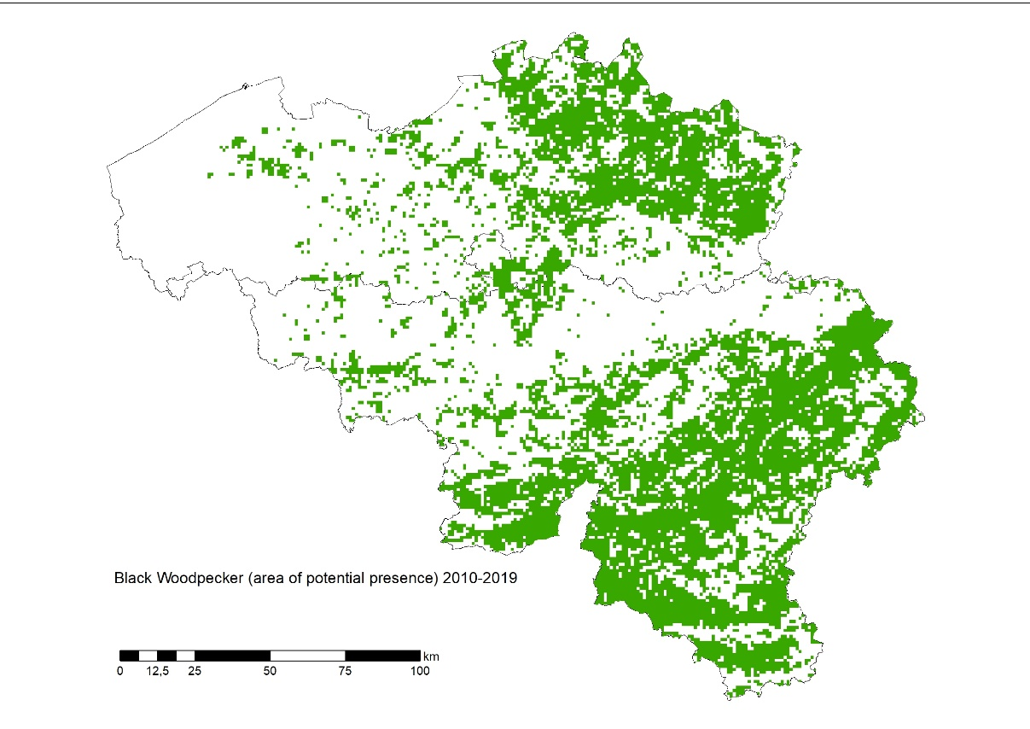
Figure S7: Modelled map for the presence of the Black Woodpecker Dryocopus martius in Belgium (green denotes where the model predicts the species to be present during the period 2010-2019.
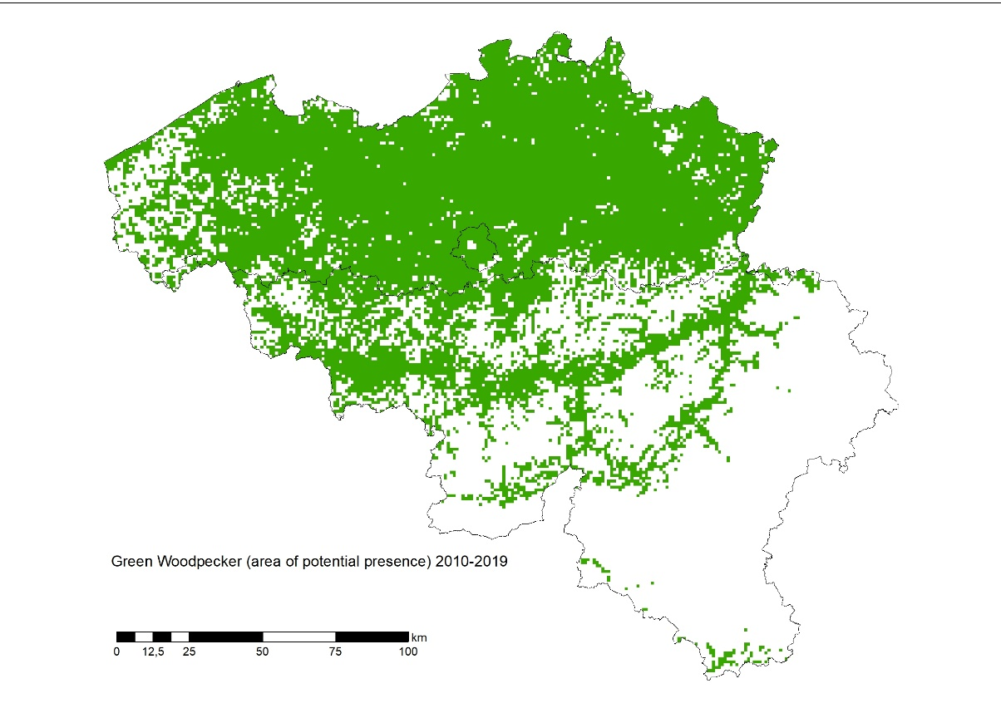
Figure S8: Modelled map for the presence of the Green Woodpecker Picus viridus in Belgium (green denotes where the model predicts the species to be present during the period 2010-2019.

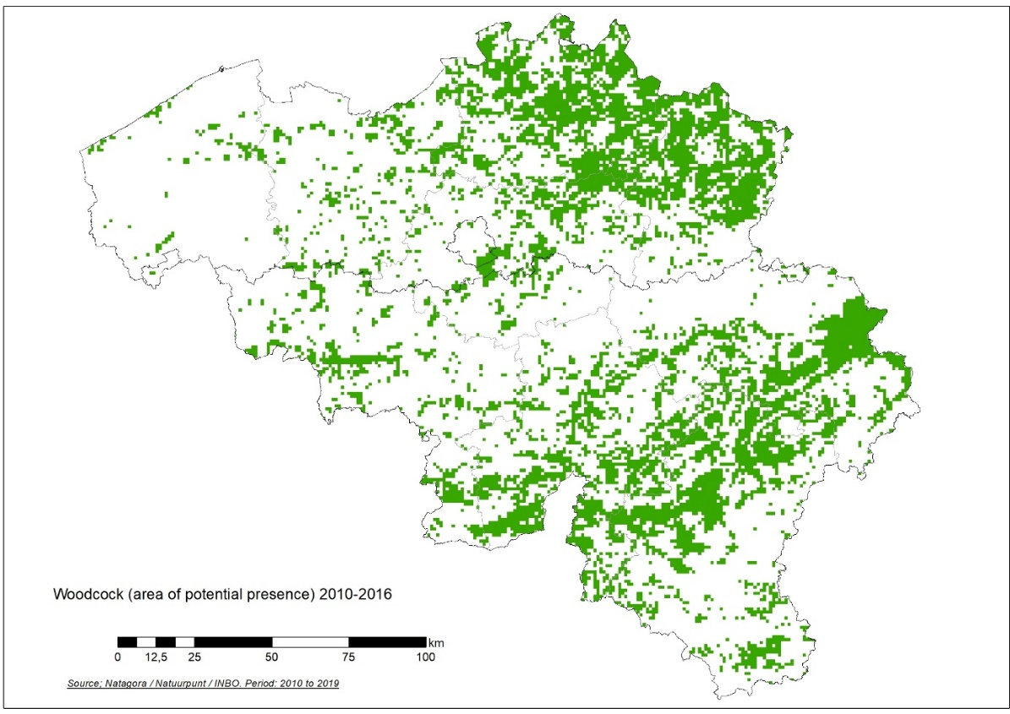
Figure S9: Modelled map for the presence of the Woodcock in Belgium (green denotes where the model predicts the species to be present, Period 2010-2016).
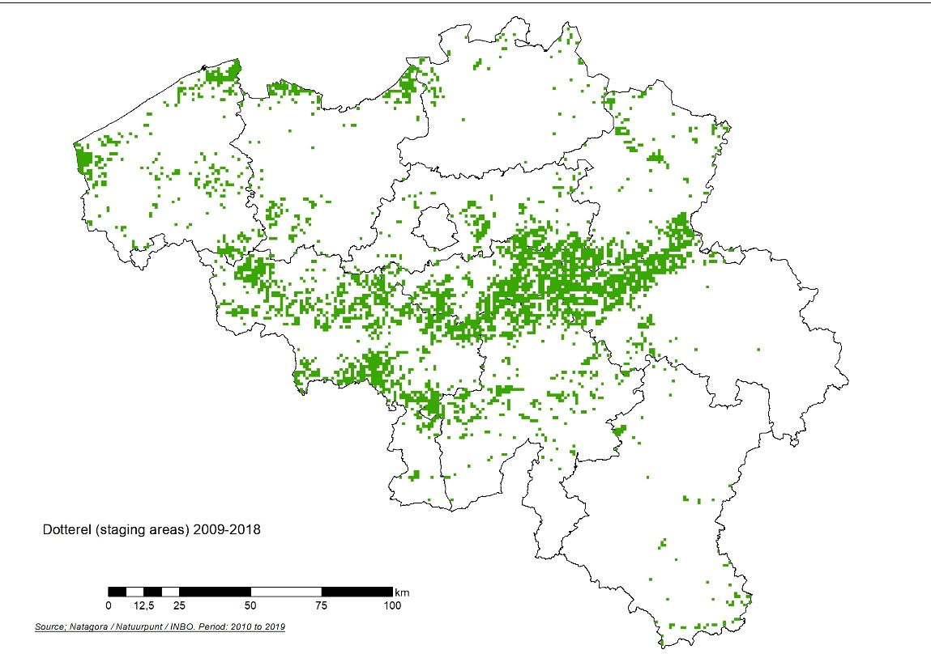
Figure S10: Staging areas of the Dotterel Eudromias morinellus in Belgium based on the modelling of occurrence records (2009-2018).
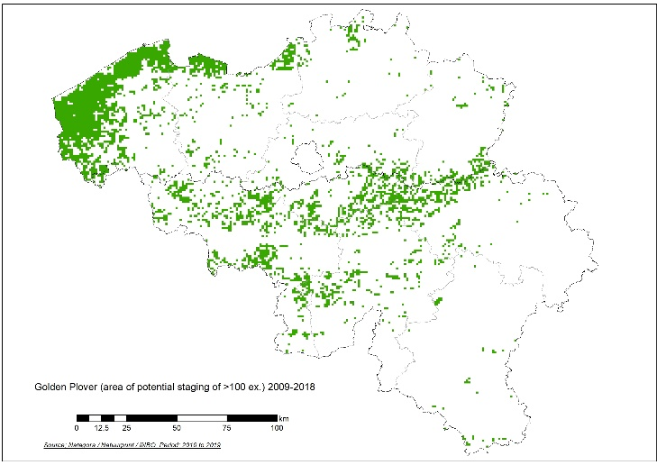
Figure S11: Staging areas of the Golden Plover in Belgium based on the modelling of occurrence records (groups of more than 100 individuals).
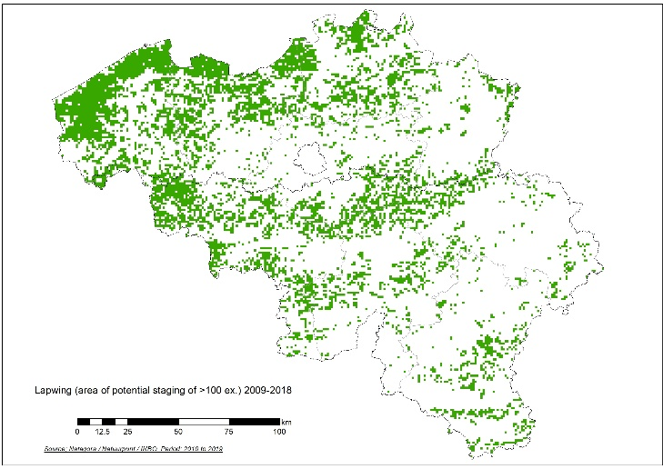
Figure S12: Staging areas of Northern Lapwings in Belgium based on the modelling of occurrence records (groups of more than 50 individuals).
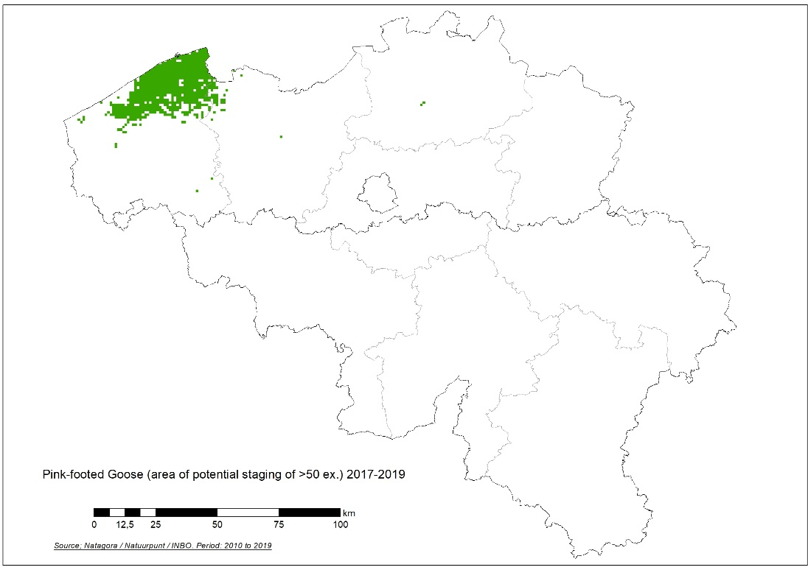
Figure S13: Staging areas of the Pink-footed Goose in Belgium based on the modelling of occurrence records (groups of more than 50 individuals).

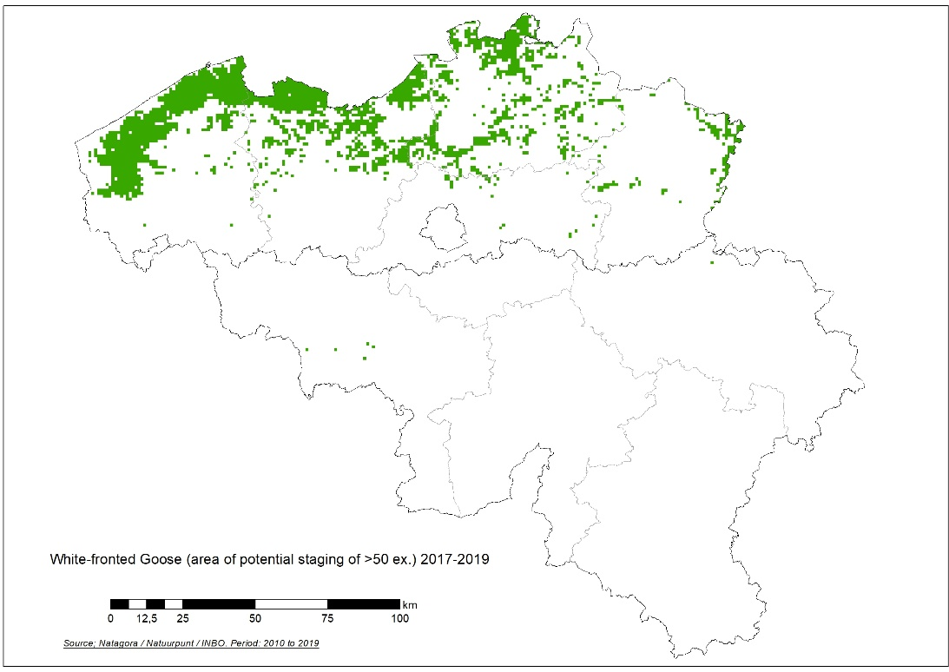
Figure S14: Staging areas of the White-fronted Goose in Belgium based on the modelling of occurrence records (groups of more than 50 individuals).
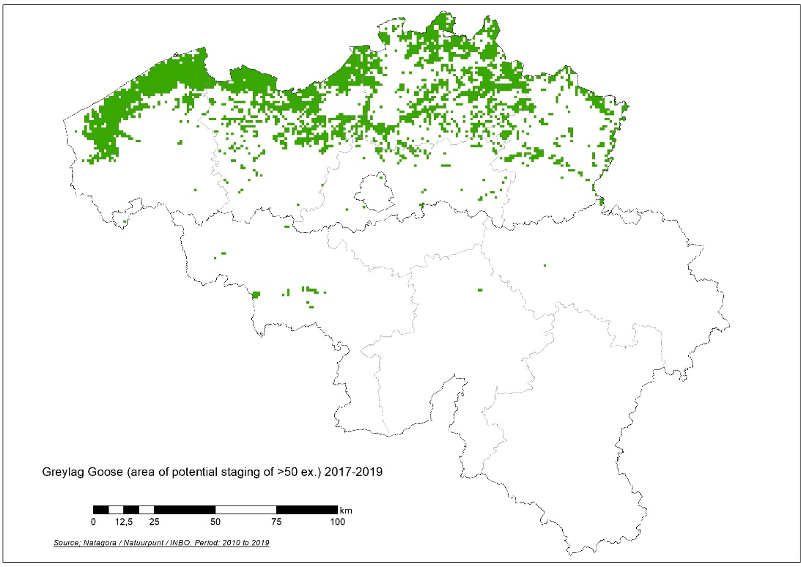
Figure S15: Staging areas of the Greylag Goose in Belgium, based on the modelling of occurrence records (groups of more than 50 individuals).
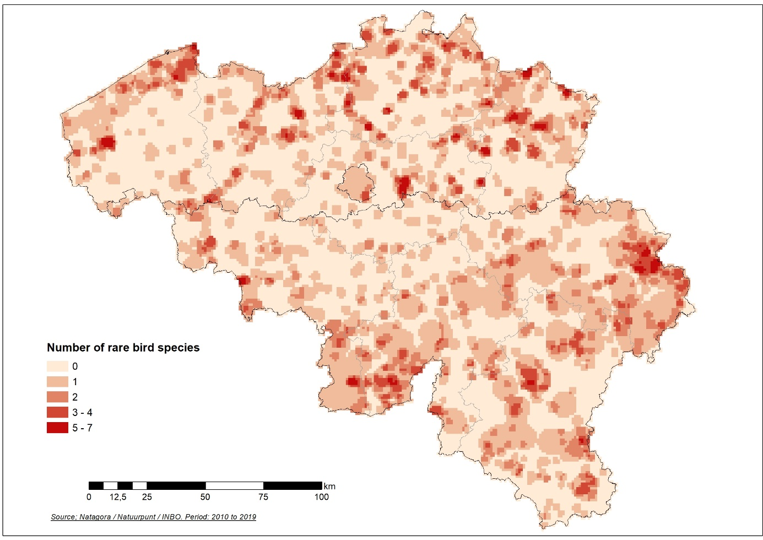
Figure S16: Squares with sensitive rare breeding species, with an indication of the number of rare breeding species for each square.
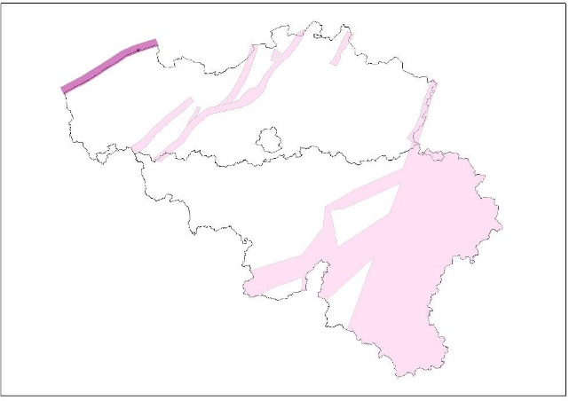
Figure S17: Proposed migration corridor map for Belgium. In violet, the major corridor of the migrants following the coastline and in pink, major inland migration corridors defined by Everaert et al. (2011) and this publication. The migration corridors in the South of Belgium are mostly defined for Woodpigeon and Common Crane.

